SMART CAMPUS PLACEMENT SYSTEM
Scope and Limitations
Department of Computer Science and Engineering, TKR College of Engineering & Technology
Batch C5 (CSE-C) · Academic year [ACADEMIC YEAR]
Table 1: Project team
S.No. | Student name | Roll number
1 | Mopidevi Bhagyasri | 23K91A05F9
2 | Pamulaparthi Harsha Vardan Reddy | 23K91A05J0
3 | Mohammad Faruk Baba | 23K91A05F3
4 | Prahalladh Terati | 23K91A05J8

Project guide: S Usha Devi
Chapter and section numbers quoted in the text (for example Chapter 8 or Section 6.2) refer to the full project report, 17.Final Document. Figures and tables in this document are numbered from 1.

1. SCOPE

1.1 In scope
The scope is what the delivered system does and was tested to do. Each item exists in the code base and has the evidence named in the last column.
Table 2: Features in scope
No. | Feature | Where | Evidence
1 | Synthetic campus dataset (3,000 students, 30 companies), reproducible with seed 42 | src/generate_dataset.py | data/*.csv, REPORT_FACTS
2 | Feature pipeline: frequency encoding, standardisation, six engineered features (24 in all) | src/preprocess.py | Unit test U2
3 | Training and comparison of six classifiers, Platt calibration and the hybrid refinement | src/hybrid_model.py | models/metrics.json; Chapter 8
4 | Placement probability, label and skill-gap tips for a student, company and role | POST /api/predict, Eligibility screen | Functional tests F1, F2; screenshot
5 | Company-role recommendation: company-only, role-only and hybrid lists, base probability, average gain, match rate | POST /api/recommend, Recommendations screen | Tests F3 to F5; Chapter 8
6 | Officer dashboard: model metrics, SHAP, PCA, probability histogram, placed rate by branch | GET /api/metrics, /api/stats, /api/plots/* | Integration tests I4 to I8
7 | Recruiter shortlist by CGPA, aptitude and branch (top 50) | POST /api/recruiter/shortlist | Test F6
8 | Companies board with tiers, cutoffs, packages and hiring rates | GET /api/companies | Test I3
9 | Original Flask interface and the React interface over the same core | app.py, backend/, frontend/ | Screens in Chapter 8

1.2 Out of scope
• Real placement data. No record of a real student or company is used.
• Accounts and permissions. There is no login for students, recruiters or officers.
• A database. The batch description names MySQL; the system reads CSV and pickle files.
• Uploading data or retraining from the interface. Retraining is by command line (python src/hybrid_model.py).
• Batch prediction from a CSV file, PDF reports and e-mail, which the base paper [1] offers.
• Matching against job-description vectors, mentioned in the batch documents.
• Resume parsing, interview scheduling, offer tracking and any communication with companies.
• Fairness and bias auditing across branches, gender or institution.

2. ASSUMPTIONS
The system and its evaluation rest on the following assumptions. Where an assumption is doubtful it is repeated as a limitation.
1. The synthetic students and the generated placement labels are a plausible stand-in for a real campus. This is an assumption, not a fact; no real data was available.
2. The 30 companies, their cutoffs, packages, locations and hiring rates are plausible; they were written by hand for the project and are not published recruiter requirements.
3. A student's placement chance depends on the student's profile and the target company's tier and cutoffs; no calendar effects, interview performance or luck other than the generator's noise are modelled.
4. The same profile fields are available for every student when the model is used (CGPA, 10th and 12th percentages, five scores, counts of projects, internships, certifications and backlogs, branch, degree).
5. The user runs the application on one PC on localhost; the back end trusts the front end's origin.
6. A placement probability of 0.5 or more means READY. The threshold is conventional and was not tuned (Chapter 8).

3. LIMITATIONS
Each limitation is stated with its consequence and with what would address it. The numbering L1 to L14 is used in the other chapters.
Table 3: Limitations
ID | Limitation | Consequence | What would address it
L1 | All student and company data are synthetic | No accuracy figure is a claim about real placements; real data are noisier (the base paper's baselines reach 0.68 to 0.73 [2]) | Data from the placement cell, with consent and anonymisation
L2 | Labels follow a logistic rule with noise (sd 0.8) | Logistic Regression is as good as or better than XGBoost; SHAP recovers the generator's rule | Real outcomes; or a generator with non-linear interactions
L3 | The hybrid gain uses true labels to pick the residual set | Accuracy 0.8400 falls to 0.8089 without them; the dashboard still reports the first | Report the label-free rule; train a classifier to recognise residual rows
L4 | One 450-student test set, one retraining study on the same 3,000 students | One student is 0.22 points; differences of 1 to 2 points are within one standard deviation | A larger real test set; temporal split by placement year
L5 | Invented company table | Cutoffs, packages and hiring rates are not real | Real recruiter requirements
L6 | No authentication, authorisation or rate limiting | Every endpoint is public, so the application is for a single machine | Roles (student, officer, recruiter), tokens and quotas
L7 | No database, no upload, no retraining from the interface | The data cannot be updated by users; changes need a script run | A database and an admin retraining job
L8 | Free-text branch and role are not validated against the training categories | An unknown value is accepted (HTTP 200) and scored with frequency 0 | Enumerations in the request models
L9 | The recommendation module reloads four pickles per candidate | 3 to 8 seconds per request (mean 5.4 s over HTTP) | Load the artefacts once per process
L10 | Recommendation ranks by probability only | Weak profiles are sent to Tier-3 companies; the role-only list is empty when the target is infeasible | Add package, interest and fit to the score; explain empty lists
L11 | Skill-gap tips are four fixed rules; SHAP is global | A tip is not an explanation of one student's probability | Per-student SHAP values; ranked actions
L12 | Pickles are tied to library versions (pandas 3 needs pyarrow) | Models may not load on other versions | Pin versions or export to a portable format
L13 | Tested on one CPU-only PC, sequential calls, no browser test suite | No statement about concurrency, other platforms or browsers | Load test, CI, cross-browser tests
L14 | Batch CSV prediction, PDF and e-mail reports, MySQL not implemented | Less functionality than the base paper's application | See Chapter 10

Two figures illustrate limitations L3 and L4. The first shows the accuracy of four models on each of five random splits: the label-free hybrid is level with calibrated XGBoost, while the paper-rule hybrid is ahead in every split. The second shows the decision-threshold analysis: accuracy is flat between 0.30 and 0.70, so the choice of threshold changes the kind of error but not the amount.
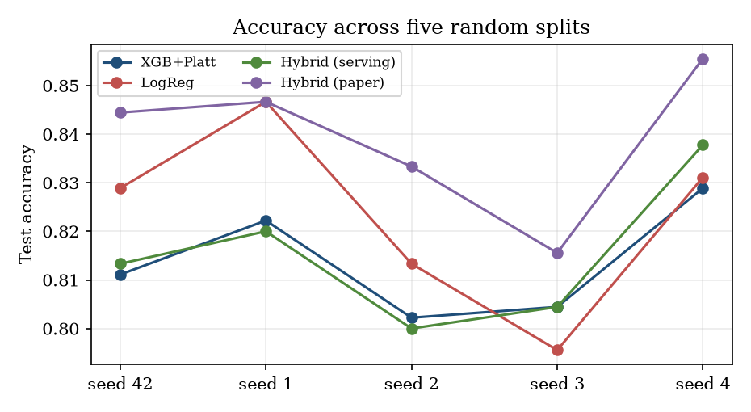
Figure 1: Test accuracy on five random splits (limitations L3 and L4).
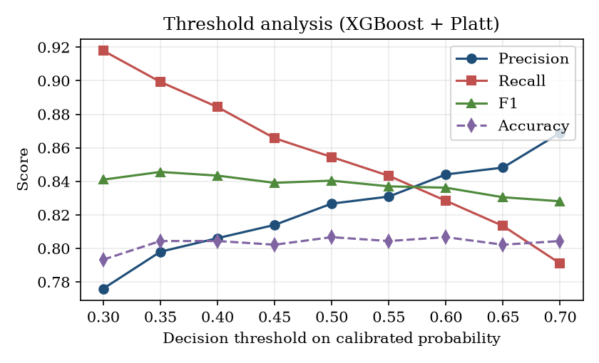
Figure 2: Precision, recall, F1 and accuracy against the decision threshold.

4. WHAT WAS NOT MEASURED
The following were not measured, and no figure for them appears in any document:
• Accuracy on real students or real companies. The data do not contain any.
• Whether recommended alternatives lead to placements. The gains are model-estimated.
• Fairness: whether the probability differs by branch, gender, school or other group for equal merit (the synthetic data have almost no branch effect by construction).
• Behaviour under concurrent users and on other hardware, operating systems or browsers.
• Usability. No user study was carried out; no satisfaction or task-time figure exists.
• Energy use and memory of training and serving.
• Accuracy of the other published works in a common comparison; their reported numbers use other data and are not reproduced here.
• The LightGBM model that the base paper compares; it is optional in the code and the package is not installed on the build machine.

